JUSTICE CAPACITY IN THE AGE OF ONE-CLICK FILING
Human-Led AI for Timely Justice
A capacity strategy for B.C. courts, tribunals and freedom-of-information systems
Give every matter a secure, source-linked AI first pass—then train accountable human decision-makers to verify, challenge and decide rather than reconstruct the file from scratch.
223 days  Median B.C. adult-criminal case time, 2023/24 [2] | 6,253  Active BCHRT complaints at 2024/25 year-end [6] | 2.18M  FOI pages processed in B.C., 2024/25 [8]
POLICY WHITE PAPER
August 2026 | British Columbia / Canada
For public-policy discussion. This paper is not legal advice and does not assess any named individual or pending case.

Executive summary
Digital tools can make filing a lawsuit, tribunal complaint or freedom-of-information request almost effortless. That is democratically valuable, but it changes the capacity problem. If public systems continue to process every file through bespoke manual reading, one-click demand can grow faster than judges, tribunal members, counsel and information officers can be recruited. The resulting queue is not merely an inconvenience: in criminal matters, delay can keep a legally innocent person in remand and create a powerful incentive to plead guilty for release.
One premise requires correction. A waiting time that remains roughly constant does not prove the backlog is artificial or that clearing it once would permanently end delay. Under Little’s Law, the average number of matters in a stable system equals the arrival rate multiplied by average time in the system: L = λW. [1] If 100 cases arrive and 100 are completed each week while 1,000 remain queued, the ten-week wait can persist indefinitely. A temporary capacity surge can drain that inventory, but permanent capacity must then exceed average arrivals enough to absorb variability and new demand.
The evidence supports a serious delay problem without proving a deliberate design to coerce pleas. Justice Canada reports that the median elapsed time for B.C. adult-criminal cases rose from 140 days in 2016/17 to 223 days in 2023/24, a 59% increase. [2] B.C. Provincial Court’s March 2026 next-available adult-criminal trial dates were 6.1, 8.2 and 9.2 months for short, medium and long trials, respectively, all above the Court’s standards; this measure starts only when a case is ready to schedule, not at charge. [4]
The B.C. Human Rights Tribunal is the clearest early-warning signal. Its active inventory grew from 1,188 complaints in 2017/18 to 6,253 in 2024/25. In the latest year it received 3,036 complaints and closed 2,704, so the stock still increased despite much higher output. [6] A 2025 chair’s update described roughly 1.5 years from filing to screening and notice and warned that one queue had been reduced partly by moving work downstream. [7]
Freedom-of-information filings do not show the claimed upward trend in B.C. General requests fell from 8,347 in 2020 to 4,691 in 2024/25, about 44%, based on the published series and legislative reporting. [9–11] Workload complexity did rise: FOI Operations processed 2.18 million pages in 2024/25 versus 1.64 million in 2020/21, while the average general-request file grew from 146 to 508 pages. [8] The honest early signal is therefore bigger files—not yet more filings. An app-enabled volume shock remains a forecast that should be scenario-tested.
Core recommendation
Create a province-wide, publicly governed AI pre-review layer for every court and tribunal matter and for FOI processing, while reserving final legal decisions to accountable humans. Replace “judge skimming” with rapid structured verification: every material fact and legal proposition must link to the record or authoritative law, and liberty, credibility, constitutional and novel-law issues receive enhanced human review.

Immediate policy decisions
- Fund a time-limited capacity surge to drain existing queues; AI is not a substitute for enough judges, tribunal members, legal aid, Crown counsel, clerks and hearing rooms.
- Build one secure evidence-and-law layer that produces a disclosed, source-linked case packet for the decision-maker and the parties.
- Pilot first in BCHRT screening/notice, FOI intake and redaction support, and high-volume uncontested procedural matters—not contested criminal guilt or sentence recommendations.
- Require independent verification and written human reasons for decisions affecting liberty, credibility, constitutional rights or novel law.
- Measure end-to-end time, remand days, plea timing, error and override rates, appeal outcomes and disparities—not just matters processed per hour.

Contents
01 Delay is a queue, an incentive and a rights problem
02 What the early indicators actually show
03 Pretrial detention and plea pressure
04 The human-led AI operating model
05 Safeguards against hallucination and automation bias
06 Implementation roadmap and capacity scenarios
07 Recommendations and next questions
08 Caveats and sources

Scope and definitions
Courts, administrative tribunals and FOI offices are not interchangeable. Courts exercise judicial power and decide liberty, rights and remedies. Tribunals apply statutory mandates through specialized procedures. FOI offices search, review, sever and disclose records under legislation; they do not adjudicate guilt. This paper proposes a shared technical discipline—secure intake, source-linked analysis, auditability and human accountability—not one algorithm making every kind of decision.
18 / 30  Jordan ceilings  Months in provincial / superior court, subject to the legal framework [3] | 1.5 years  BCHRT intake delay  Approximate filing-to-screening/notice in early 2025 [7] | +248%  FOI file size  146 to 508 average pages, 2020/21–2024/25 [8]

1. Delay is a queue, an incentive and a rights problem

Stable waiting time can be a real, stable backlog
Little’s Law is simple: L = λW, where L is average inventory, λ is average arrival rate and W is average time in the system. [1] If arrivals and completions are balanced, the queue need not grow—but it also does not disappear. Stable waiting time can therefore mean a stable stock of unfinished work. If arrivals rise above completions, inventory and delay grow; if completions exceed arrivals for long enough, the backlog shrinks.
Illustrative weekly scenario | Arrivals λ | Capacity μ | Backlog movement | Implication
Stable queue | 100 | 100 | 0 per week | A 1,000-case inventory and roughly ten-week wait can persist.
Drain campaign | 100 | 200 | −100 per week | A 1,000-case queue drains in about ten weeks if no other bottleneck moves downstream.
App-enabled shock | 140 | 130 | +10 per week | Even a 30% capacity gain loses ground after 40% demand growth.
Resilient steady state | 100 average | 115 usable | Usually negative | Headroom absorbs variation, complex cases, leave and outages.

These are illustrative arithmetic examples, not forecasts. Real justice systems have multiple queues—intake, disclosure, scheduling, hearing, reasons and enforcement. Improving one stage may initially expose the next bottleneck, exactly as the BCHRT has reported. [7]

Delay can coerce without being intentionally engineered
The evidence does not establish that B.C. maintains a backlog to manufacture guilty pleas. Intent is difficult to infer from aggregate waiting times. The functional effect is nevertheless serious: an accused person denied bail may compare many more months in remand while asserting innocence against a plea that produces immediate or earlier release. A nominally voluntary choice can be made under profound temporal pressure.
The policy response should not depend on proving a conspiracy. It should remove the pressure mechanism: presumptive release where risk can be managed, rapid bail review, early disclosure, enforceable timelines, sufficient defence capacity and timely trial.

Court delay measures are not interchangeable
Justice Canada’s national indicator measures elapsed time from first appearance to final decision for completed adult-criminal cases. [2] B.C. Provincial Court’s “time to trial” report measures the interval from the ready-to-schedule date to the next available trial date. [4] Neither alone equals the full lived time from investigation or charge to verdict. A public dashboard should show the complete path and each stage separately.

2. What the early indicators actually show

B.C. criminal case times have risen over the longer horizon
Justice Canada reports a Canadian median of 169 days in 2016/17 and 217 days in 2023/24. B.C. moved from 140 to 223 days over the same period, a 59% increase; the latest year increased from 219 to 223 days. About 9% of Canadian cases were identified as potentially at risk of exceeding the Jordan ceilings in 2023/24, though “at risk” is not the same as a judicial stay and reasons for withdrawal or stay vary. [2–3]
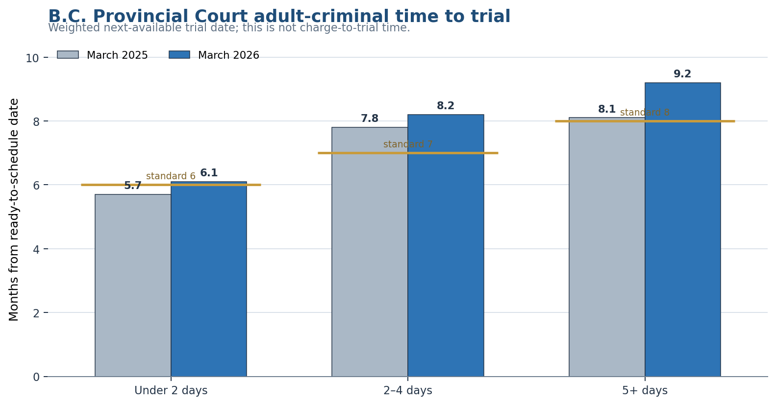
Source: Provincial Court of British Columbia [4–5]. The measure begins when the case is ready to schedule and therefore understates full charge-to-trial elapsed time.

BCHRT shows a sustained stock-and-flow imbalance
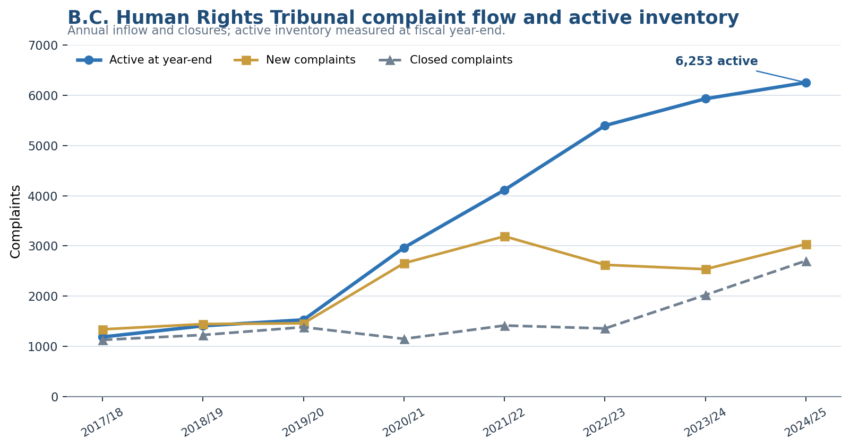
Source: B.C. Human Rights Tribunal annual reports, summarized in the 2024/25 report [6]. Active inventory is a stock; new and closed complaints are annual flows.
The Tribunal’s output improved—closures rose from 2,023 in 2023/24 to 2,704 in 2024/25—but new complaints rose even faster, to 3,036. The active inventory therefore increased from 5,930 to 6,253. Only 61 hearings and 35 final decisions were reported in 2024/25, while 739 preliminary decisions were issued; many complaints resolve or are screened without a merits hearing. [6] This is precisely why stage-specific triage and clear reasons matter.

FOI is a complexity warning, not a filing-growth trend
B.C. FOI indicator | 2020 / 2020/21 | 2024/25 | Direction
General requests | 8,347 | 4,691 | Down about 44% [9–11]
Pages processed | 1.64 million | 2.18 million | Up about 33% [8]
Average pages per general-request file | 146 | 508 | Up about 248% [8]
Share that are personal-information requests | Not used here | 60% | Large candidate for direct-access reform [8]

The general-request decline may partly reflect the $10 application fee introduced in 2021, but this paper does not assign a single cause. [11] The more defensible conclusion is that fewer general requests can still produce more page review. A filing app could reverse the volume trend; that possibility should be modelled as a scenario and monitored from launch, not represented as an observed increase that has already occurred.
Design implication
The same app that simplifies filing should reduce duplicate requests, search already-released records, ask clarifying questions and produce structured metadata. Good access technology lowers friction for the public and lowers avoidable work for the institution.

3. Pretrial detention and plea pressure

The legal plea standard is necessary but not sufficient
Section 606 of the Criminal Code requires a guilty plea to be voluntary and informed, to reflect an understanding of the essential elements and consequences, and to rest on facts supporting the charge; the court is not bound by any agreement. [14] That safeguard addresses the plea in court. It cannot by itself erase the leverage created when the alternative is many more months in custody.
Justice Canada’s review notes that Canada does not maintain a comprehensive national guilty-plea dataset and cites older estimates that roughly 90% of criminal cases resolve by guilty plea. It also reports Canadian research in which people held in remand were about twice as likely to plead guilty as those released on bail, alongside qualitative accounts of pleading to “get it over with,” escape remand or avoid repeated adjournments. [12–13] These sources support concern about systemic pressure; they do not establish that every remand plea is false.

Acquittal does not restore the lost time
A person acquitted after pretrial detention does not automatically receive compensation for the lost months, employment, housing or family contact. Canada’s compensation arrangements are narrow, discretionary and historically focused on wrongful convictions rather than every justified acquittal after detention. [16] This asymmetry makes speed and cautious remand decisions especially important.

Low-level or context-dependent charges heighten the risk
Some offences turn on mental state and context that a charge label can obscure. For example, Criminal Code section 351 does not criminalize mere possession of an ordinary tool. It requires possession, without lawful excuse, of an instrument suitable for breaking into a place or vehicle while knowing it has been used or is intended for that purpose. [15] Early evidence mapping can identify whether the alleged knowledge and intended use are actually supported, reducing pressure to plead simply because the charge sounds more serious than the provable facts.

Procedural reforms that should precede and accompany AI
- Rapid bail hearings, funded release plans and automatic short-interval review of contested remand.
- Crown file-sufficiency screening before a charge proceeds and enforceable early-disclosure deadlines.
- A single digital chronology and exhibit index shared by prosecution, defence and court, with correction rights.
- Early judicial case conferences focused on admissions, disclosure gaps, legal issues and realistic trial length.
- Remote procedural appearances where appropriate, while preserving an in-person option and accessibility.
- A funded backlog-drain team and sufficient legal aid so speed does not mean an unrepresented accused being rushed.
- Public reporting of remand days, plea timing relative to bail decisions, adjournment reasons, stays and withdrawals.

4. The human-led AI operating model

Universal first pass; proportional human depth
Every filed matter should receive a secure AI-assisted first pass, because standardization is most valuable when it is universal. Human attention should then scale with consequence and uncertainty. A consent order, a repetitive procedural request, a novel Charter issue and a contested criminal trial should not receive the same review path.
Layer | What the system produces | Human responsibility
0 — Structured intake | Party and record metadata, duplicate detection, missing fields, deadlines, accessibility and language needs. | Clerk confirms identity, filing status and corrections.
1 — Procedural triage | Jurisdiction, limitation flags, service status, required forms, disclosure gaps and proposed next step. | Authorized official decides acceptance, notice, extensions and procedural directions.
2 — Source-linked analysis | Chronology; issue map; fact-to-evidence table; contradictions; governing law with paragraph links; strongest arguments; missing proof; neutral questions. | Decision-maker and parties verify the record, correct errors and identify disputed issues.
3 — Drafting support | Candidate structure for reasons and neutral language, with every material proposition linked to the record or law. | Human decides outcome, writes or substantively adopts reasons, and remains publicly accountable.
4 — Enhanced review | Second-model or second-human check, uncertainty report, constitutional/credibility checklist and adversarial challenge log. | Mandatory for liberty, credibility, constitutional rights, novel law and irreversible harm.

The decision packet
- A one-page procedural posture and requested relief.
- A dated chronology in which every entry opens the underlying record.
- An elements-and-evidence matrix: admitted, disputed, unsupported or legally irrelevant.
- Both parties’ strongest version of the case, including an unrepresented party’s discernible position.
- Applicable legislation and cases from an authenticated legal source, linked to the exact provision or paragraph.
- Uncertainty and conflict flags, including missing disclosure and credibility questions the system cannot resolve.
- A correction log visible to the parties and the decision-maker.

Retraining the judicial role
The goal is not to turn judges into passive skimmers. “Skimming” invites automation bias: a polished memo can feel correct even when the premise or citation is wrong. The safer role is rapid structured verification. Judges and tribunal members should be trained to test the issue map, open material citations, sample the record, challenge the system’s strongest counterargument, identify what depends on credibility and state their independent reasons.
This remains consistent with the Canadian Judicial Council’s 2024 guidance, which encourages education and carefully governed support while warning against delegation of judicial decision-making, undue reliance, opaque reasoning and insecure use. [17] The Chief Justice of Canada has likewise described AI as capable of supporting but never replacing judicial decision-making. [18]

5. Safeguards against hallucination and automation bias

Non-negotiable controls
Risk | Required control | Public evidence
False facts or citations | Retrieval only from the filed record and authenticated law; no unsupported proposition in the decision packet. | Citation-validity and record-link failure rate.
Automation bias | Mandatory verification checklist, strongest-counterargument prompt, random double review and minimum review depth for high-stakes matters. | Human disagreement, override and correction rates.
Unequal arms | Provide the same core packet to all parties; fund access for legal aid and unrepresented people. | Usage and correction outcomes by representation status.
Hidden reasoning | Disclose material AI-generated analysis used by the decision-maker, subject to lawful privilege and security limits. | Disclosure compliance and objections resolved.
Privacy and security | Canadian-controlled secure environment, role-based access, encryption, no training on sealed files, short retention and immutable logs. | Audit results, access incidents and deletion compliance.
Bias and drift | Pre-deployment testing, subgroup outcome monitoring, version freeze per matter and revalidation after model changes. | Disparity, calibration and drift reports.
Rubber-stamped reasons | Human attestation that material facts and law were checked; reasons must address the losing party’s central argument. | Appeal, reconsideration and template-similarity audits.

What must not be automated first
- Final determinations of guilt, detention, sentence or involuntary treatment.
- Credibility findings based on demeanour, context or contested testimony.
- Charter and constitutional rulings, novel legal questions and departures from precedent.
- Risk scores derived from protected traits or opaque proxies.
- Plea recommendations presented to an accused as if generated by the court.

Canadian courts are already setting a verification norm
The Federal Court requires parties to declare certain AI-generated content and warns of sanctions for non-compliance or unreliable material. [19] B.C. Provincial Court’s July 2026 guidance tells court users and lawyers to verify AI content and notes potential consequences for inaccurate or fabricated material. [20] The proposed public system should meet a higher standard than litigants: authenticated sources, logged versions, secure deployment and measurable error rates.
Accountability rule
The institution may use AI to prepare analysis; it may not use AI to diffuse responsibility. The named human decision-maker owns the decision and reasons.

6. Implementation roadmap and capacity scenarios

Start where the value is high and the stakes are bounded
Pilot | First use | Explicit exclusion | 12-month success test
BCHRT | Intake completeness, duplicate detection, jurisdiction and screening memo, notice package. | No autonomous dismissal or credibility finding. | Lower filing-to-notice p90 without higher reconsideration or subgroup disparity.
FOI Operations | Clarification, duplicate-release search, record inventory, severance suggestions and exemption citation. | No final withholding decision by AI. | More pages processed per staff hour with no privacy breach or disclosure-quality decline.
Provincial Court | Uncontested procedural applications, disclosure map, chronology and case conference packet. | No guilt, detention, plea or sentence recommendation. | Shorter ready-to-trial time and fewer adjournments without more appeals or corrections.

A staged four-year program
Period | Deliverable | Gate
0–6 months | Governance statute/policy, data map, procurement, baseline dashboard, staff/party co-design and sandbox. | Privacy, security, Indigenous data-governance and judicial-independence review.
6–18 months | Three bounded pilots, capacity surge for existing inventory, public incident register and independent evaluation. | No expansion unless accuracy, fairness and time metrics pass pre-set thresholds.
18–30 months | Shared evidence/law layer, disclosed correction portal, training certification and province-wide procedural support. | External audit plus appeal/reconsideration analysis.
30–48 months | Broader pre-review across all matters, with proportional human review and enhanced high-stakes pathway. | Legislative renewal after public report and rights-impact review.

Scenario planning, not productivity mythology
AI time savings should be modelled net of verification, correction, security and disclosure work. If analysts or decision-makers spend 40% of their time on record synthesis, a tool that halves only that task does not double total capacity; the gross gain is about 20% before new overhead. A pilot should test 15%, 30% and 45% net improvements rather than promise an unverified multiple.
Illustrative net capacity gain | If arrivals stay at 100/week | If app-enabled arrivals reach 140/week
15% | Capacity 115; backlog drains 15/week. | Backlog grows 25/week.
30% | Capacity 130; backlog drains 30/week. | Backlog grows 10/week.
45% | Capacity 145; backlog drains 45/week. | Backlog drains only 5/week.

The implication is structural: filing technology and adjudication technology must be planned together. Even a successful AI tool can be overwhelmed if demand grows faster. Intake design, duplicate prevention, early resolution, staffing and service simplification remain essential.

The public scorecard
- Inventory, arrivals and completions at every stage; median and 90th-percentile end-to-end time.
- Criminal remand days, bail-review time, adjournment reason, plea timing and representation status.
- AI citation failure, material factual error, party correction, human override and unresolved-objection rates.
- Reconsideration, appeal, reversal and remittal rates, compared with non-AI baseline cases.
- Outcomes and delays by Indigenous identity, race, sex, disability, region, language and representation status, using lawful and co-designed governance.
- Staff time by task, net operating cost, security incidents and user-reported procedural fairness.

7. Recommendations
- Adopt “AI pre-review for every matter; human judgment for every decision” as the governing policy.
- Fund a temporary backlog-drain capacity surge and permanent headroom; do not count software licences as judicial capacity.
- Create one authenticated record-and-law layer that produces source-linked chronologies, issue maps and evidence matrices.
- Disclose the material decision packet to parties, provide a correction route and fund equal access for defence and unrepresented litigants.
- Train and certify judges, tribunal members and officers in rapid structured verification, automation bias, source checking, uncertainty and secure use.
- Apply enhanced review to liberty, credibility, constitutional rights, novel law and irreversible harm; prohibit autonomous final decisions in those areas.
- Pilot first in BCHRT intake, FOI processing and bounded procedural court work, with independent evaluation and public error reporting.
- Pair the technology with bail, disclosure, legal-aid, scheduling and case-management reforms that directly remove plea pressure.
- Publish stage-level queue data and app-driven demand scenarios so the public can distinguish stable inventory, worsening backlog and shifted bottlenecks.

Questions for the next design phase
1. Which B.C. institution should own the shared technical platform without compromising judicial and tribunal independence?
2. What parts of an AI-generated decision packet must be disclosed, and how should privilege, sealed records and informer information be protected?
3. What minimum human-review protocol is appropriate for each risk tier, and how will compliance be audited?
4. How should the province compensate people who spend substantial time in remand and are then acquitted or have charges withdrawn?
5. What demand increase should be stress-tested before launching one-click civil, tribunal and FOI filing tools?
6. Which process rules can be simplified or removed so AI does not merely accelerate unnecessary complexity?

Caveats and assumptions
- A stable delay does not prove intentional manipulation. The plea-pressure concern rests on functional incentives and remand evidence, not a finding of institutional bad faith.
- B.C. court-time measures use different start and end points. The 223-day median and Provincial Court next-available dates should not be added or directly equated.
- The FOI evidence contradicts a rising-count claim: general requests declined in the cited period. Page volume and average file size rose. Future app-driven filings are a scenario, not an observed trend.
- Justice Canada’s plea evidence includes older and qualitative research and no complete national plea dataset. It establishes a credible concern, not a count of factually innocent pleas.
- AI productivity gains in this paper are illustrative scenarios. Verification, privacy, security, disclosure and appeals can offset gross time savings.
- Source-linked AI can still omit evidence, encode bias or generate persuasive error. Human accountability and adversarial correction are essential, not ceremonial.
- This paper is policy analysis, not legal advice, a judicial directive or a conclusion about any pending matter.

Sources
All web sources were last accessed 29 August 2026. Monetary amounts are Canadian dollars unless stated otherwise.
[1] A proof for the queuing formula L = λW — Operations Research, 1961. Little’s Law applies under stable long-run conditions.
[2] Criminal court delay indicators after R. v. Jordan — Department of Justice Canada, updated 2025.
[3] R. v. Jordan, 2016 SCC 27 — Supreme Court of Canada, 2016.
[4] Time to Trial Update — March 31, 2026 — Provincial Court of British Columbia, 2026.
[5] Time to Trial Update — March 31, 2025 — Provincial Court of British Columbia, 2025.
[6] Annual Report 2024/25 — B.C. Human Rights Tribunal, 2025.
[7] Update from the Chair on backlog and delay — B.C. Human Rights Tribunal, 2025.
[8] Improving digital service delivery with FOIPPA amendments — Government of British Columbia, 2026.
[9] Annual report on the administration of FOIPPA, 2024/25 — Government of British Columbia, 2025.
[10] Official Report of Debates, March 11, 2026 — Legislative Assembly of British Columbia, 2026.
[11] Bill 9: B.C. plans big changes to freedom of information rules — The Narwhal, 2026. Secondary cross-check for the historical general-request count and 44% decline.
[12] Guilty pleas among Indigenous people in Canada — Part III — Department of Justice Canada, 2017.
[13] Guilty pleas among Indigenous people in Canada — Part V — Department of Justice Canada, 2017.
[14] Criminal Code, section 606 — Pleas — Justice Laws Website, current to 2026.
[15] Criminal Code, section 351 — Possession of break-in instrument — Justice Laws Website, current to 2026.
[16] Miscarriages of justice commission consultation report — Department of Justice Canada, 2022. Describes Canada’s narrow and largely ex gratia compensation framework for wrongful convictions.
[17] Guidelines for the use of artificial intelligence in Canadian courts — Canadian Judicial Council, 2024.
[18] Remarks on artificial intelligence and the judiciary — Chief Justice of Canada Richard Wagner, 2025.
[19] Artificial intelligence: notice to the parties and profession — Federal Court, updated 2025.
[20] Artificial intelligence in court documents — Provincial Court of British Columbia, 2026.

